**ASSIGNMENT 2**

**NAME : PRIYADHARSHINI M**

**REG NO :**  **812019205027**

**Build a python code, Assume u get temperature and humidity values (generated with random function to a variable) and write a condition to continuously detect alarm in case of high temperature.**

**Code:**

import random

while(True):

temp=random.randint(10,99)

humid=random.randint(10,99)

print("current temperature:",temp)

print("current humidity:",humid,"%")

temp_ref=37

humid_ref=35

if temp>temp_ref and humid<humid_ref:

print("Sound Alarm")

else:

print("Sound off")

break

**Result:**

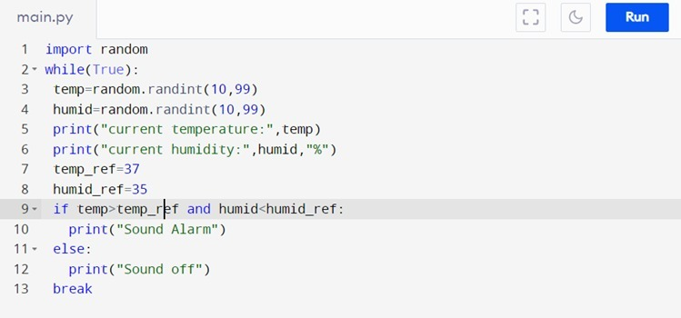

Output:

